Occupational Health Branch • California Department of Public Health • January 2014

Use this “camera” ready or editable article for your newsletter, blog, or listserv(s) to encourage your members to use safer substitutes instead of methylene-chloride-containing paint removers. Please credit the Occupational Health Branch, California Department of Public Health.

Toxic Paint Removers: Safer Choices

Deaths among construction workers who were using a paint remover containing methylene chloride (MeCl) prompted the California Department of Public Health (CDPH) to issue two methylene chloride fatality alerts and a health hazard alert. Now, new information is available on safer products.
MeCl is a chemical solvent widely used in paint strippers, metal cleaners, and degreasers. Workers may be exposed when refinishing cabinetry, removing paint or coatings from wood, steel or other surfaces, manufacturing foam products, painting with epoxy paints, and spraying adhesives. CDPH recommends that contractors, workers and other users always read product labels and Safety Data Sheets (SDS) to find out whether MeCl is in the product.
In 2011 CDPH learned that methylene chloride-based paint strippers had caused the deaths of at least 13 contractors/workers nationwide who were refinishing bathtubs. When inhaled, MeCl affects the central nervous system (the brain) causing headaches, nausea, dizziness, clumsiness, drowsiness, and eventually, unconsciousness and death. MeCl evaporates quickly from liquid and can build up to lethal concentrations in air - especially in enclosed spaces such as bedrooms, bathrooms and garages where paint strippers are commonly used. Since MeCl can easily go through skin, getting MeCl on your skin can contribute to overall exposure. In addition, MeCl is a chemical known to cause cancer.
In order to prevent future deaths and health problems from MeCl, CDPH recommends that all who use these products:

- Find out if methylene chloride is in products you use. Become familiar with the health hazards from methylene chloride in paint strippers.

- Use less toxic alternative choices: See guide to choosing safer paint stripping products http://www.cdph.ca.gov/programs/hesis/Documents/Paint-Removal-Methods.pdf

- Display this poster of safer paint strippers at your worksite and use it to conduct chemical hazard awareness training http://www.cdph.ca.gov/programs/ohb/Documents/PaintRemovalPoster.pdf

- Use proper personal protective equipment and adequate ventilation if paint strippers containing methylene chloride are used. See guide to personal protective equipment for paint strippers. http://www.cdph.ca.gov/programs/ohb/Documents/PPEChart.pdf
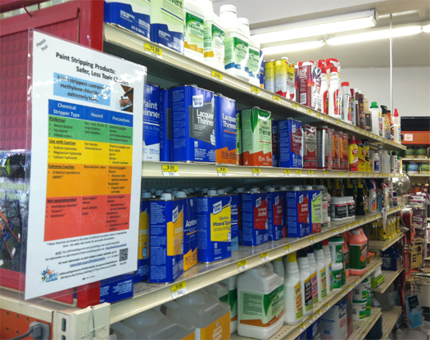
Safer paint stripping product choices poster at paint store

You can also find more information on the CDPH website Preventing Worker Deaths from Paint Strippers Containing Methylene Chloride: http://www.cdph.ca.gov/programs/ohb/Pages/methylenechloride.aspx or you can call the Hazard Evaluation System and Information Service at CDPH with questions about methylene chloride and other workplace hazards at
866-282-5516 (toll-free in California).

