

<YOur name>  
<District Name>

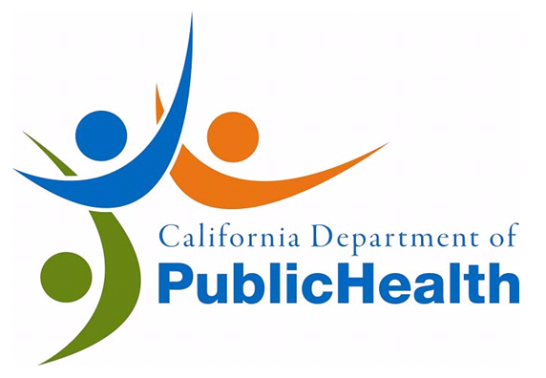

**AWARD**

to recognize and honor

<CUSTODIAN NAME>

<Title>, <School>

for expertise and participation in completing the  
**Cleaning for Asthma Safe Schools Project**  
We thank you for taking an important step in reducing environmental asthma risks and protecting children’s and workers’ health.

The California Department of Public Health (CDPH), Green Schools Initiative, and the <District Name> hereby award this

**CERTIFICATE OF COMMENDATION**

Given on <MOnth> <day>, <Year>.