Following four simple steps at home
— Clean, Separate, Cook, and Chill —
can help protect you and your loved ones from food poisoning.
Icon | Step and details
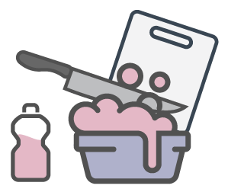 | Step 1: Clean your hands and kitchen surfaces  Wash your hands and the surfaces where you prepare food with warm, soapy water before you begin cooking.
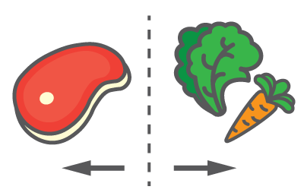 | Step 2: Separate raw meat from other food  Keep raw meat, poultry, seafood, and eggs away from ready-to-eat foods that won’t be cooked. Germs from raw meat can easily spread to other food if you don’t keep them separate.
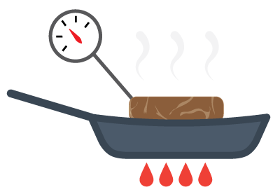 | Step 3: Cook food to the right temperature  Heat food to the right temperature to kill any germs that can make you sick. Use a food thermometer to make sure meat has been fully cooked.
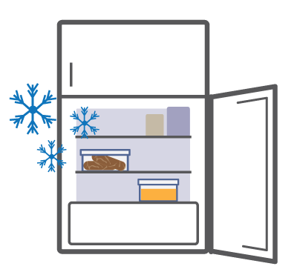 | Step 4: Chill leftovers  Refrigerate perishable food right away to prevent germs from growing. Germs can grow in food if left out at room temperature.

